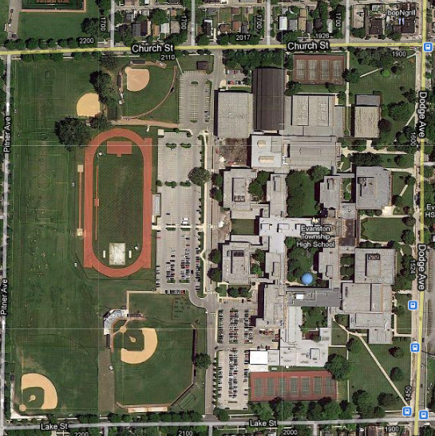

**ATHLETIC OFFICE**

**QUAD GYMS**

**BOYS LOCKER ROOM**

**TRACK**

**AND**

**FIELD**

**POOL**

**ATR**

**UPSTAIRS GYMS**

**WRESTLING ROOM**

**B**

**BEARDSLEY**

**WEIGHT ROOM**

**GYMNASTICS**

**GIRLS LOCKER ROOM**

**LOWER LEVEL SOFTBALL**

**CHURCH**

**COURTS**

**FIELDHOUSE**

**LAKE COURTS**

**VARSITY**

**SOFTBALL**

**VARSITY BASEBALL**

**LOWER LEVEL BASEBALL**

**LAKE FIELD**

**PITNER SOUTH FIELD**

**CHURCH-PITNER FIELD**

**PITNER NORTH FIELD**

**MEMORIAL STADIUM**



**ATHLETIC OFFICE**

**QUAD GYMS**

**BOYS LOCKER ROOM**

**TRACK**

**AND**

**FIELD**

**POOL**

**ATR**

**UPSTAIRS GYMS**

**WRESTLING ROOM**

**BEARDSLEY**

**WEIGHT ROOM**

**GYMNASTICS**

**GIRLS LOCKER ROOM**

**LOWER LEVEL SOFTBALL**

**CHURCH**

**COURTS**

**FIELDHOUSE**

**LAKE COURTS**

**VARSITY**

**SOFTBALL**

**VARSITY BASEBALL**

**LOWER LEVEL BASEBALL**

**LAKE FIELD**

**PITNER SOUTH FIELD**

**CHURCH-PITNER FIELD**

**PITNER NORTH FIELD**

**MEMORIAL STADIUM**