Baseball Fields: Emergency Entrances
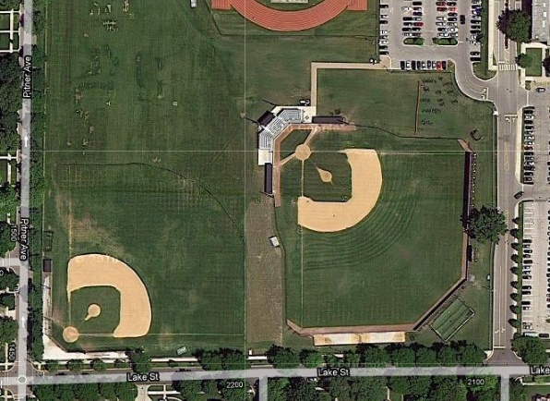
2
1
AWAY DUGOUT
HOME DUGOUT
LOWER LEVEL BASEBALL
VARSITY BASEBALL
- To reach the Varsity baseball field, enter the rear parking lot via Lake Street, and turn left into the west lot. The gate is located just north of the field in the southwest corner of the parking lot. (1)
- The entrance to the lower level baseball field is on Lake Street just east of Pitner Avenue. (2)

