Activation of Emergency Medical Services
- Call 911. You must provide:
  - Your name
  - Location of injured athlete
    - ETHS is located at 1600 Dodge Avenue
    - Please indicate which gym the athlete is in: G160, G170, G165, or G175.
  - Number of individuals injured
  - Condition of athlete(s)
    - Conscious or unconscious?
    - Is he/she breathing
    - Has severe bleeding?
    - In shock?
  - First aid treatment provided
    - Splinting?
    - Wound care?
    - CPR/AED?
  - Any other information requested by the dispatcher

- You MUST call the Safety Department. Please provide:
  - Your name
  - Location of injured athlete
  - Number of individuals injured
  - Notify them that you have called EMS to the scene

Sample EMS Call
My name is (your name) and I am calling from the Quad Gyms at ETHS. We have (number of individuals injured) athlete(s) who need immediate medical attention in Gym (160, 170, 165, or 175). The athlete is condition of athlete) . Our athletic trainers are on the scene and have provided (first aid care) . Please enter the high school using (Door 50) , which is accessible from the rear parking lot and is near the bicycle rack compound.

What is my role?
Coaches
- Be prepared to assist with CPR, AED administration, or other life saving techniques
- Keep other players off the court a safe distance away from the injured athlete
- Call athlete’s emergency contact, bring parent to the sideline if he/she is in the stands
Athletic Director
- If present, assist coaching staff
Athletic Trainers
- Attend to injured athlete
- Designate person to call 911
- Designate athletic training student to alert safety
Team Physician
- If present, attend to injured athlete
Athletic Training Students
- Assist ATCs by bringing equipment to the court
- Alert Safety upon request
- Assist Safety personnel in directing EMS to injury site
Safety
- Maintain crowd control to allow for quick and easy entrance of EMS personnel
- Meet EMS personnel and direct them to venue/injury site
- Obtain a written report for records; a copy must be provided to the athletic trainers when complete

Quad Gyms: Emergency Entrances
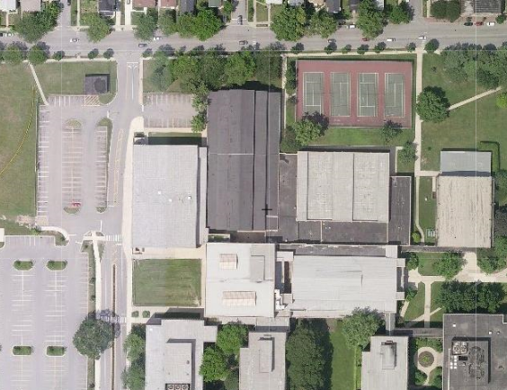
BIKE RACKS
CHURCH STREET
QUAD GYMS
DOOR 50

- To enter the rear parking lot, enter the high school via Church Street.

- Follow the pathway on the left-hand side of the bike racks to Door 50.

- To reach the Quad Gyms, enter through Door 50 and make a left down the hallway. The gyms are located at the end of the hallway on the right hand side.

Emergency Resources

Chris Attaway, ATC
Athletic Trainer
Office: 847-424-7358
Cell: 405-314-4831

Lucy Walsh, ATC
Athletic Trainer
Office: 847-424-7373
Cell: 773-480-0194

Chris Livatino
Athletic Director
Office: 847-424-7380
Cell: 847-417-7651

Mike Burzawa
Assistant Athletic Director
Office: 847-424-7390
Cell: 630-675-8302

Dr. Andrew Hunt
Team Physician
Office: 847-724-4384
Cell: 847-323-5546

Safety Department
847-424-7500

Illinois Bone and Joint Urgent Care Clinic
2350 Ravine Way, Suite 600
Glenview, IL 60025
847-832-6006

North Shore University Health Systems
Evanston Hospital
2650 Ridge Ave
Evanston, IL 60201
847-570-2000

