Activation of Emergency Medical Services
- Call 911. You must provide:
  - Your name
  - Location of injured athlete
    - ETHS is located at 1600 Dodge Avenue
    - Direct access to Beardsley Gym is available through Door 18, which is on the East side of the school on Dodge Avenue. If a stretcher is necessary, please enter through Door 22 to access the ramp.
  - Number of individuals injured
  - Condition of athlete(s)
    - Conscious or unconscious?
    - Is he/she breathing
    - Has severe bleeding?
    - In shock?
  - First aid treatment provided
    - Splinting?
    - Wound care?
    - CPR/AED?
  - Any other information requested by the dispatcher

- You MUST call the Safety Department. Please provide:
  - Your name
  - Location of injured athlete
  - Number of individuals injured
  - Notify them that you have called EMS to the scene

Sample EMS Call
My name is (your name) and I am calling from Beardsley Gym at ETHS. We have (number of individuals injured) athlete(s) who need immediate medical attention. The athlete is (condition of athlete) . Our athletic trainers are on the scene and have provided (first aid care) . Please enter the high school using Door 18/ Door 22 , which is accessible from Dodge Avenue.

What is my role?
Coaches
- Be prepared to assist with CPR, AED administration, or other life saving techniques
- Keep other players off the court a safe distance away from the injured athlete
- Call athlete’s emergency contact, bring parent to the sideline if he/she is in the stands
Athletic Director
- If present, assist coaching staff
Athletic Trainers
- Attend to injured athlete
- Designate person to call 911
- Designate athletic training student to alert safety
Team Physician
- If present, attend to injured athlete
Athletic Training Students
- Assist ATCs by bringing equipment to the court
- Alert Safety upon request
- Assist Safety personnel in directing EMS to injury site
Safety
- Maintain crowd control to allow for quick and easy entrance of EMS personnel
- Meet EMS personnel and direct them to venue/injury site
- Obtain a written report for records; a copy must be provided to the athletic trainers when complete

Beardsley Gymnasium Emergency Entrances

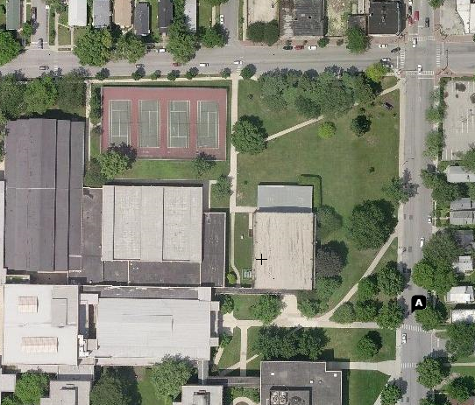
DOOR 22
DOOR 18
CHURCH STREET
BEARDSLEY GYM

- Door 18 leads directly to Beardsley Gym.
- If a stretcher is needed, please instruct EMS to enter through Door 22 for ease of access.
DODGE AVENUE

Emergency Resources

Chris Attaway, ATC
Athletic Trainer
Office: 847-424-7358
Cell: 405-314-4831

Lucy Walsh, ATC
Athletic Trainer
Office: 847-424-7373
Cell: 773-480-0194

Chris Livatino
Athletic Director
Office: 847-424-7380
Cell: 847-417-7651

Mike Burzawa
Assistant Athletic Director
Office: 847-424-7390
Cell: 630-675-8302

Dr. Andrew Hunt
Team Physician
Office: 847-724-4384
Cell: 847-323-5546

Safety Department
847-424-7500

Illinois Bone and Joint Urgent Care Clinic
2350 Ravine Way, Suite 600
Glenview, IL 60025
847-832-6006

North Shore University Health Systems
Evanston Hospital
2650 Ridge Ave
Evanston, IL 60201
847-570-2000

