Activation of Emergency Medical Services
- Call 911. You must provide:
  - Your name
  - Location of injured athlete
    - ETHS is located at 1600 Dodge Avenue, Evanston IL 60201
    - Use Door 50 to enter the high school
  - Number of individuals injured
  - Condition of athlete(s)
    - Conscious or unconscious?
    - Is he/she breathing
    - Has severe bleeding?
    - In shock?
  - First aid treatment provided
    - Splinting?
    - Wound care?
    - CPR/AED?
  - Any other information requested by the dispatcher

- You MUST call the Safety Department. Please provide:
  - Your name
  - Location of injured athlete
  - Number of individuals injured
  - Notify them that you have called EMS to the scene

Sample EMS Call
My name is (your name) and I am calling from the girls’ locker room at ETHS. We have (number of individuals injured) athlete(s) who need immediate medical attention. The athlete is (condition of athlete) . Our athletic trainers are on the scene and have provided (first aid care) . Please enter the rear parking lot via Church Street. Follow the pathway on the left-hand side of the bike rack compound to reach Door 50. Once inside, make a right and continue until you see the girls’ locker room on your right-hand side.

What is my role?
Coaches
- Be prepared to assist with CPR, AED administration, or other life saving techniques
- Keep athletes and staff a safe distance away from the injured athlete
- Call athlete’s emergency contact, bring parent to the area if they are on school grounds
Athletic Director
- If present, assist coaching staff
Athletic Trainers
- Attend to injured athlete
- Designate person to call 911
- Designate athletic training student to alert safety
Team Physician
- If present, attend to injured athlete
Athletic Training Students
- Assist ATCs by bringing equipment to the site
- Alert Safety upon request
- Assist Safety personnel in directing EMS to injury site
Safety
- Maintain crowd control to allow for quick and easy entrance of EMS personnel
- Meet EMS personnel and direct them to venue/injury site
- Obtain a written report for records; a copy must be provided to the athletic trainers when complete

Girls’ Locker Rooms: Emergency Entrances
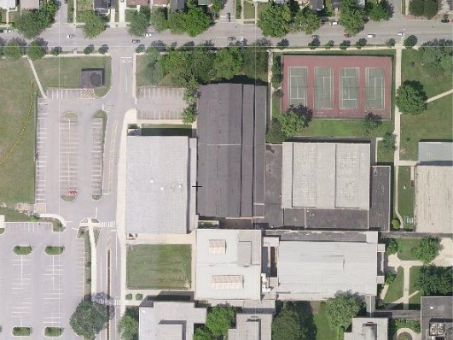
CHURCH STREET
BIKE RACKS
DOOR 50
- Enter the rear parking lot via Church Street.

- Follow the pathway on the left-hand side of the bike racks to reach Door 50.

- Once inside, make a right and continue until you reach the girls’ locker room which will be on the right-hand side.

Emergency Resources

Chris Attaway, ATC
Athletic Trainer
Office: 847-424-7358
Cell: 405-314-4831

Lucy Walsh, ATC
Athletic Trainer
Office: 847-424-7373
Cell: 773-480-0194

Chris Livatino
Athletic Director
Office: 847-424-7380
Cell: 847-417-7651

Mike Burzawa
Assistant Athletic Director
Office: 847-424-7390
Cell: 630-675-8302

Dr. Andrew Hunt
Team Physician
Office: 847-724-4384
Cell: 847-323-5546

Safety Department
847-424-7500

Illinois Bone and Joint Urgent Care Clinic
2350 Ravine Way, Suite 600
Glenview, IL 60025
847-832-6006

North Shore University Health Systems
Evanston Hospital
2650 Ridge Ave
Evanston, IL 60201
847-570-2000

