Activation of Emergency Medical Services
- Call 911. You must provide:
  - Your name
  - Location of injured athlete
    - ETHS is located at 1600 Dodge Avenue, Evanston IL 60201
    - Indicate whether the athlete is located Church-Pitner, Pitner North, Pitner South, or Lake Field.
- The primary entrance to the Church-Pitner Field is located at the corner of Church Street and Pitner Avenue.
- Entrances to the Pitner North and South fields are located adjacent to each field on Pitner Avenue as indicated by the arrows.
- The entrance to Lake Field is on Lake Street just east of Pitner Avenue.
  - Number of individuals injured
  - Condition of athlete(s)
    - Conscious or unconscious?
    - Is he/she breathing
    - Has severe bleeding?
    - In shock?
  - First aid treatment provided
    - Splinting?
    - Wound care?
    - CPR/AED?
  - Any other information requested by the dispatcher

- You MUST call the Safety Department. Please provide:
  - Your name
  - Location of injured athlete
  - Number of individuals injured
  - Notify them that you have called EMS to the scene
Sample EMS Call
My name is (your name) and I am calling from the (Church-Pitner, Pitner North, Pitner South, Lake) field at ETHS. We have (number of individuals injured) athlete(s) who need immediate medical attention. The athlete is (condition of athlete) . Our athletic trainers are on the scene and have provided (first aid care) . Please enter at (the corner of Church and Pitner) OR (Pitner Avenue between Church and Lake) OR (Lake Street between Grey and Pitner Avenue).
What is my role?
Coaches
- Be prepared to assist with CPR, AED administration, or other life saving techniques
- Keep players off the field a safe distance away from the injured athlete
- Call athlete’s emergency contact, bring parent to sideline if he/she is in the stands
- Open nearest gate if LSDA key available
Athletic Director
- If present, assist coaching staff
Athletic Trainers
- Attend to injured athlete
- Designate person to call 911
- Designate athletic training student to alert safety
Team Physician
- If present, attend to injured athlete
Athletic Training Students
- Assist ATCs by bringing equipment to the field
- Alert Safety upon request
- Assist Safety personnel in directing EMS to injury site
Safety
- Maintain crowd control to allow for quick and easy entrance of EMS personnel
- Meet EMS personnel and direct them to venue/injury site
- Obtain a written report for records; a copy must be provided to the athletic trainers when complete

Pitner Fields: Emergency Entrances
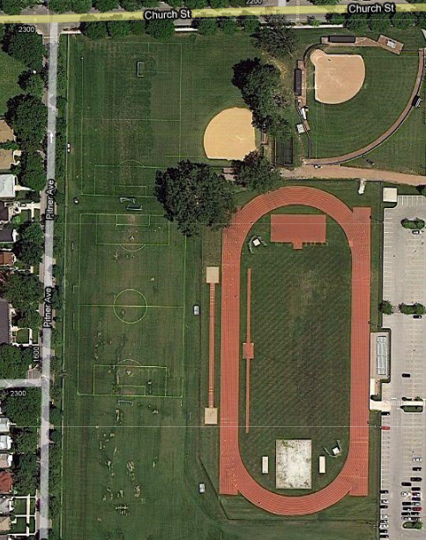
PITNER SOUTH FIELD
PITNER NORTH FIELD
CHURCH-PITNER FIELD
- The primary entrance to the Church-Pitner field is located at the corner of Church Street and Pitner Avenue.

- Entrances to the Pitner North and South fields are located adjacent to each field on Pitner Avenue as indicated by the arrows.
Lake Field: Emergency Entrances

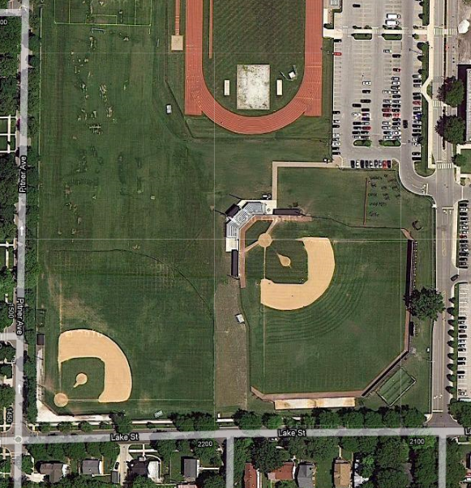
GREY AVE
LAKE FIELD
PITNER SOUTH FIELD
LAKE FIELD
PITNER SOUTH FIELD
- The entrance to Lake Field is on Lake Street just east of Pitner Avenue. A coach or safety officer may need to open the gate to let EMS enter.

Emergency Resources

Chris Attaway, ATC
Athletic Trainer
Office: 847-424-7358
Cell: 405-314-4831

Lucy Walsh, ATC
Athletic Trainer
Office: 847-424-7373
Cell: 773-480-0194

Chris Livatino
Athletic Director
Office: 847-424-7380
Cell: 847-417-7651

Mike Burzawa
Assistant Athletic Director
Office: 847-424-7390
Cell: 630-675-8302

Dr. Andrew Hunt
Team Physician
Office: 847-724-4384
Cell: 847-323-5546

Safety Department
847-424-7500

Illinois Bone and Joint Urgent Care Clinic
2350 Ravine Way, Suite 600
Glenview, IL 60025
847-832-6006

North Shore University Health Systems
Evanston Hospital
2650 Ridge Ave
Evanston, IL 60201
847-570-2000

