Softball Fields: Emergency Entrances
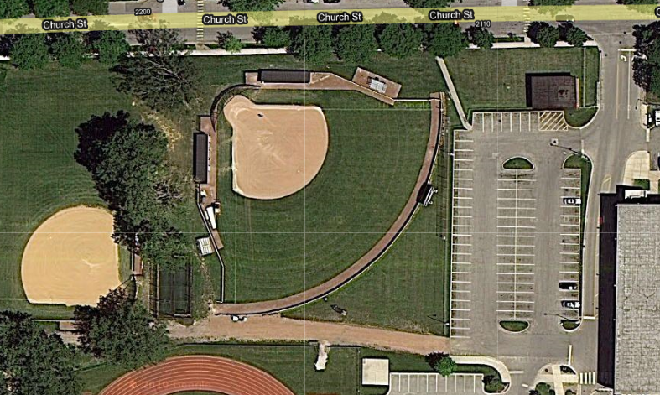
BLEACHERS
BLEACHERS
HOME DUGOUT
AWAY DUGOUT
LOWER LEVEL SOFTBALL
VARSITY SOFTBALL
- EMS may use the gravel path on the west side of the parking lot to directly access both the varsity and lower level softball fields.
- Additionally, a sidewalk at the northwest corner of the parking lot may be used to reach the varsity field’s away team dugout or bleachers.

