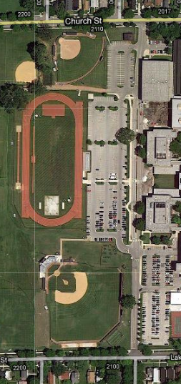

**Track and Field: Emergency Entrances**

* To reach the north entrance of the track, EMS should enter the rear parking lot from Church Street and turn left into the small west parking lot bordering the softball field. The gravel path on the west side of parking lot to leads directly to the track, and the ambulance may continue to drive onto the track if needed.
* A second entrance is located near the middle of the large west parking lot next to the track and field bleachers. EMS may use either Church Street or Lake Street to quickly reach this gate.

**LAKE STREET**

**BLEACHERS**