Activation of Emergency Medical Services
- Call 911. You must provide:
  - Your name
  - Location of injured athlete
    - Please indicate whether the athlete is in the gymnastics facility or weight room
- Door 34 is the fastest way to access the gymnastics facilities and weight room. In the event of a time sensitive emergency (damage to the artery, athlete is not breathing, cardiac arrest) instruct EMS to send personnel through this entrance.
    - There is no elevator access at Door 34; if a stretcher is needed, EMS should bring it through Door 25
  - Number of individuals injured
  - Condition of athlete(s)
    - Conscious or unconscious?
    - Is he/she breathing
    - Has severe bleeding?
  - First aid treatment provided
    - Splinting?
    - Wound care?
    - CPR/AED?
  - Any other information requested by the dispatcher

- You MUST call the Safety Department. Please provide:
  - Your name
  - Location of injured athlete
  - Number of individuals injured
  - Notify them that you have called EMS to the scene=
Sample EMS Call
My name is (your name) and I am calling from the Quad Gyms at ETHS. We have (number of individuals injured) athlete(s) who need immediate medical attention in the (gymnastics facility/weight room). The athlete is (condition of athlete) . Our athletic trainers are on the scene and have provided (first aid care) . Please enter the rear parking lot via Church Street. Use (Door 34 and/or Door 25) to get to the upstairs gyms. Door 34 is located off of the small east parking lot that is immediately to your left upon entering the lot. Door 25 is located near the loading dock at the south end of the rear parking lot.
What is my role?
Coaches
- Be prepared to assist with CPR, AED administration, or other life saving techniques
- Keep athletes and staff a safe distance away from the injured athlete
- Call athlete’s emergency contact, bring parent to sideline if he/she is in the stands
Athletic Director
- If present, assist coaching staff
Athletic Trainers
- Attend to injured athlete
- Designate person to call 911
- Designate athletic training student to alert safety
Team Physician
- If present, attend to injured athlete
Athletic Training Students
- Assist ATCs by bringing equipment to the court
- Alert Safety upon request
- Assist Safety personnel in directing EMS to injury site
Safety
- Maintain crowd control to allow for quick and easy entrance of EMS personnel
- Meet EMS personnel and direct them to venue/injury site
- Obtain a written report for records; a copy must be provided to the athletic trainers when complete

Gymnastics and Weight Room: Emergency Entrances
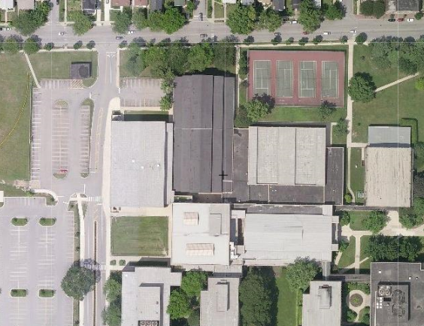
DOOR 34
UPSTAIRS GYMS
TO DOOR 25
CHURCH STREET
- Door 34 is the fastest way to access the upstairs gyms. In the event of a time sensitive emergency (damage to the artery, athlete is not breathing, cardiac arrest) instruct EMS to send personnel through this entrance.

- Once inside the building, take the stairs to the second floor. G206-207 will be the gyms immediately to the right. G208-209 will be farther down the hall, also on the right.

- There is no elevator access at Door 34; if a stretcher is needed, EMS should bring it through Door 25 which is indicated on the following page.

Upstairs Gyms: Emergency Entrances
TO DOOR 34
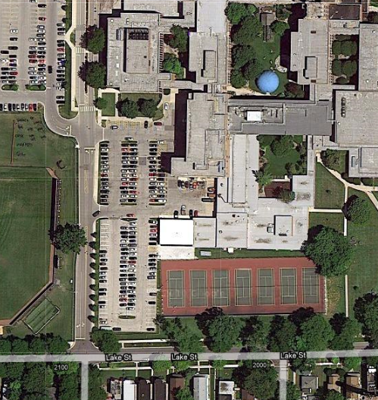
LOADING DOCK
LAKE STREET
DOOR 25

- After entering through Door 25, make a right followed by an immediate left into the “South Wing” hallway. Follow signs toward the “H” hallway – the elevator is located in the “H” hallway, which will be on the right hand side.
- A safety officer will meet EMS to allow elevator access and direct them to the 2nd floor entrance to the gymnastics facility/weight room. It is located at the end of the “West Wing.”
- Pass through the gymnastics facility and weight room to reach G208-209 and G206-207.
Emergency Resources

Chris Attaway, ATC
Athletic Trainer
Office: 847-424-7358
Cell: 405-314-4831

Lucy Walsh, ATC
Athletic Trainer
Office: 847-424-7373
Cell: 773-480-0194

Chris Livatino
Athletic Director
Office: 847-424-7380
Cell: 847-417-7651

Mike Burzawa
Assistant Athletic Director
Office: 847-424-7390
Cell: 630-675-8302

Dr. Andrew Hunt
Team Physician
Office: 847-724-4384
Cell: 847-323-5546

Safety Department
847-424-7500

Illinois Bone and Joint Urgent Care Clinic
2350 Ravine Way, Suite 600
Glenview, IL 60025
847-832-6006

North Shore University Health Systems
Evanston Hospital
2650 Ridge Ave
Evanston, IL 60201
847-570-2000

