Activation of Emergency Medical Services
- Call 911. You must provide:
  - Your name
  - Location of injured athlete
    - ETHS is located at 1600 Dodge Avenue, Evanston IL 60201
    - Use Door 44 to enter the Wrestling Room
      - Located to the left of the bike rack compound in the rear parking lot
  - Number of individuals injured
  - Condition of athlete(s)
    - Conscious or unconscious?
    - Is he/she breathing
    - Has severe bleeding?
    - In shock?
  - First aid treatment provided
    - Splinting?
    - Wound care?
    - CPR/AED?
  - Any other information requested by the dispatcher

- You MUST call the Safety Department. Please provide:
  - Your name
  - Location of injured athlete
  - Number of individuals injured
  - Notify them that you have called EMS to the scene

Sample EMS Call
My name is (your name) and I am calling from the Wrestling Room at ETHS. We have (number of individuals injured) athlete(s) who need immediate medical attention. The athlete is (condition of athlete) . Our athletic trainers are on the scene and have provided (first aid care) . Please enter the rear parking lot via Church Street and continue straight until you reach the bike rack compound. Door 44 provides direct access to the Wrestling Room and is just left of the bike racks.
What is my role?
Coaches
- Be prepared to assist with CPR, AED administration, or other life saving techniques
- Keep players off the field a safe distance away from the injured athlete
- Call athlete’s emergency contact, bring parent to sideline if he/she is in the stands
Athletic Director
- If present, assist coaching staff
Athletic Trainers
- Attend to injured athlete
- Designate person to call 911
- Designate athletic training student to alert safety
Team Physician
- If present, attend to injured athlete
Athletic Training Students
- Assist ATCs by bringing equipment to the field
- Alert Safety upon request
- Assist Safety personnel in directing EMS to injury site
Safety
- Maintain crowd control to allow for quick and easy entrance of EMS personnel
- Meet EMS personnel and direct them to venue/injury site
- Obtain a written report for records; a copy must be provided to the athletic trainers when complete

Wrestling Room: Emergency Entrances
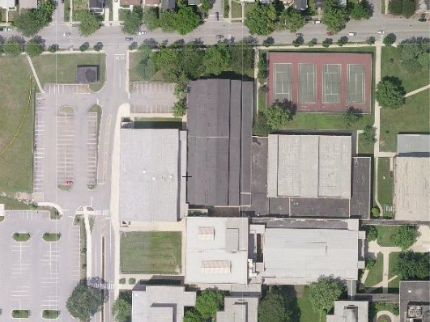
CHURCH STREET
BIKE RACKS
DOOR 44
- Door 44 leads directly to the Wrestling Room. It is located to the left of the bike racks in the rear parking lot.

Emergency Resources

Chris Attaway, ATC
Athletic Trainer
Office: 847-424-7358
Cell: 405-314-4831

Lucy Walsh, ATC
Athletic Trainer
Office: 847-424-7373
Cell: 773-480-0194

Chris Livatino
Athletic Director
Office: 847-424-7380
Cell: 847-417-7651

Mike Burzawa
Assistant Athletic Director
Office: 847-424-7390
Cell: 630-675-8302

Dr. Andrew Hunt
Team Physician
Office: 847-724-4384
Cell: 847-323-5546

Safety Department
847-424-7500

Illinois Bone and Joint Urgent Care Clinic
2350 Ravine Way, Suite 600
Glenview, IL 60025
847-832-6006

North Shore University Health Systems
Evanston Hospital
2650 Ridge Ave
Evanston, IL 60201
847-570-2000

